WSM 205 S

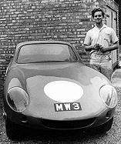

Mike White is pictured on collection of his lightweight fibreglass bodied WSM from Wing in 1963 . .

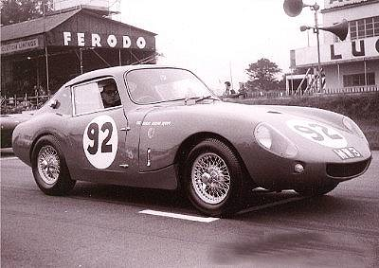

Mike raced Turners prior to the spaceframe design WSM, pictured at Goodwood in 1963 . .

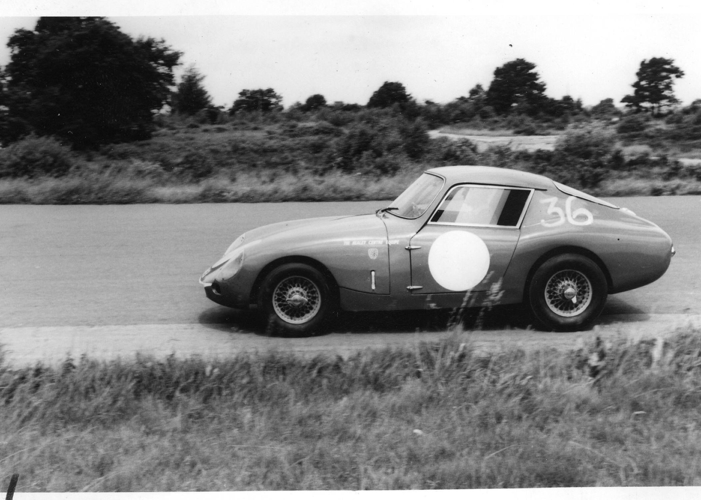

Bill Viney owned the car in the 1966, and Brian Overton in 1968 . .

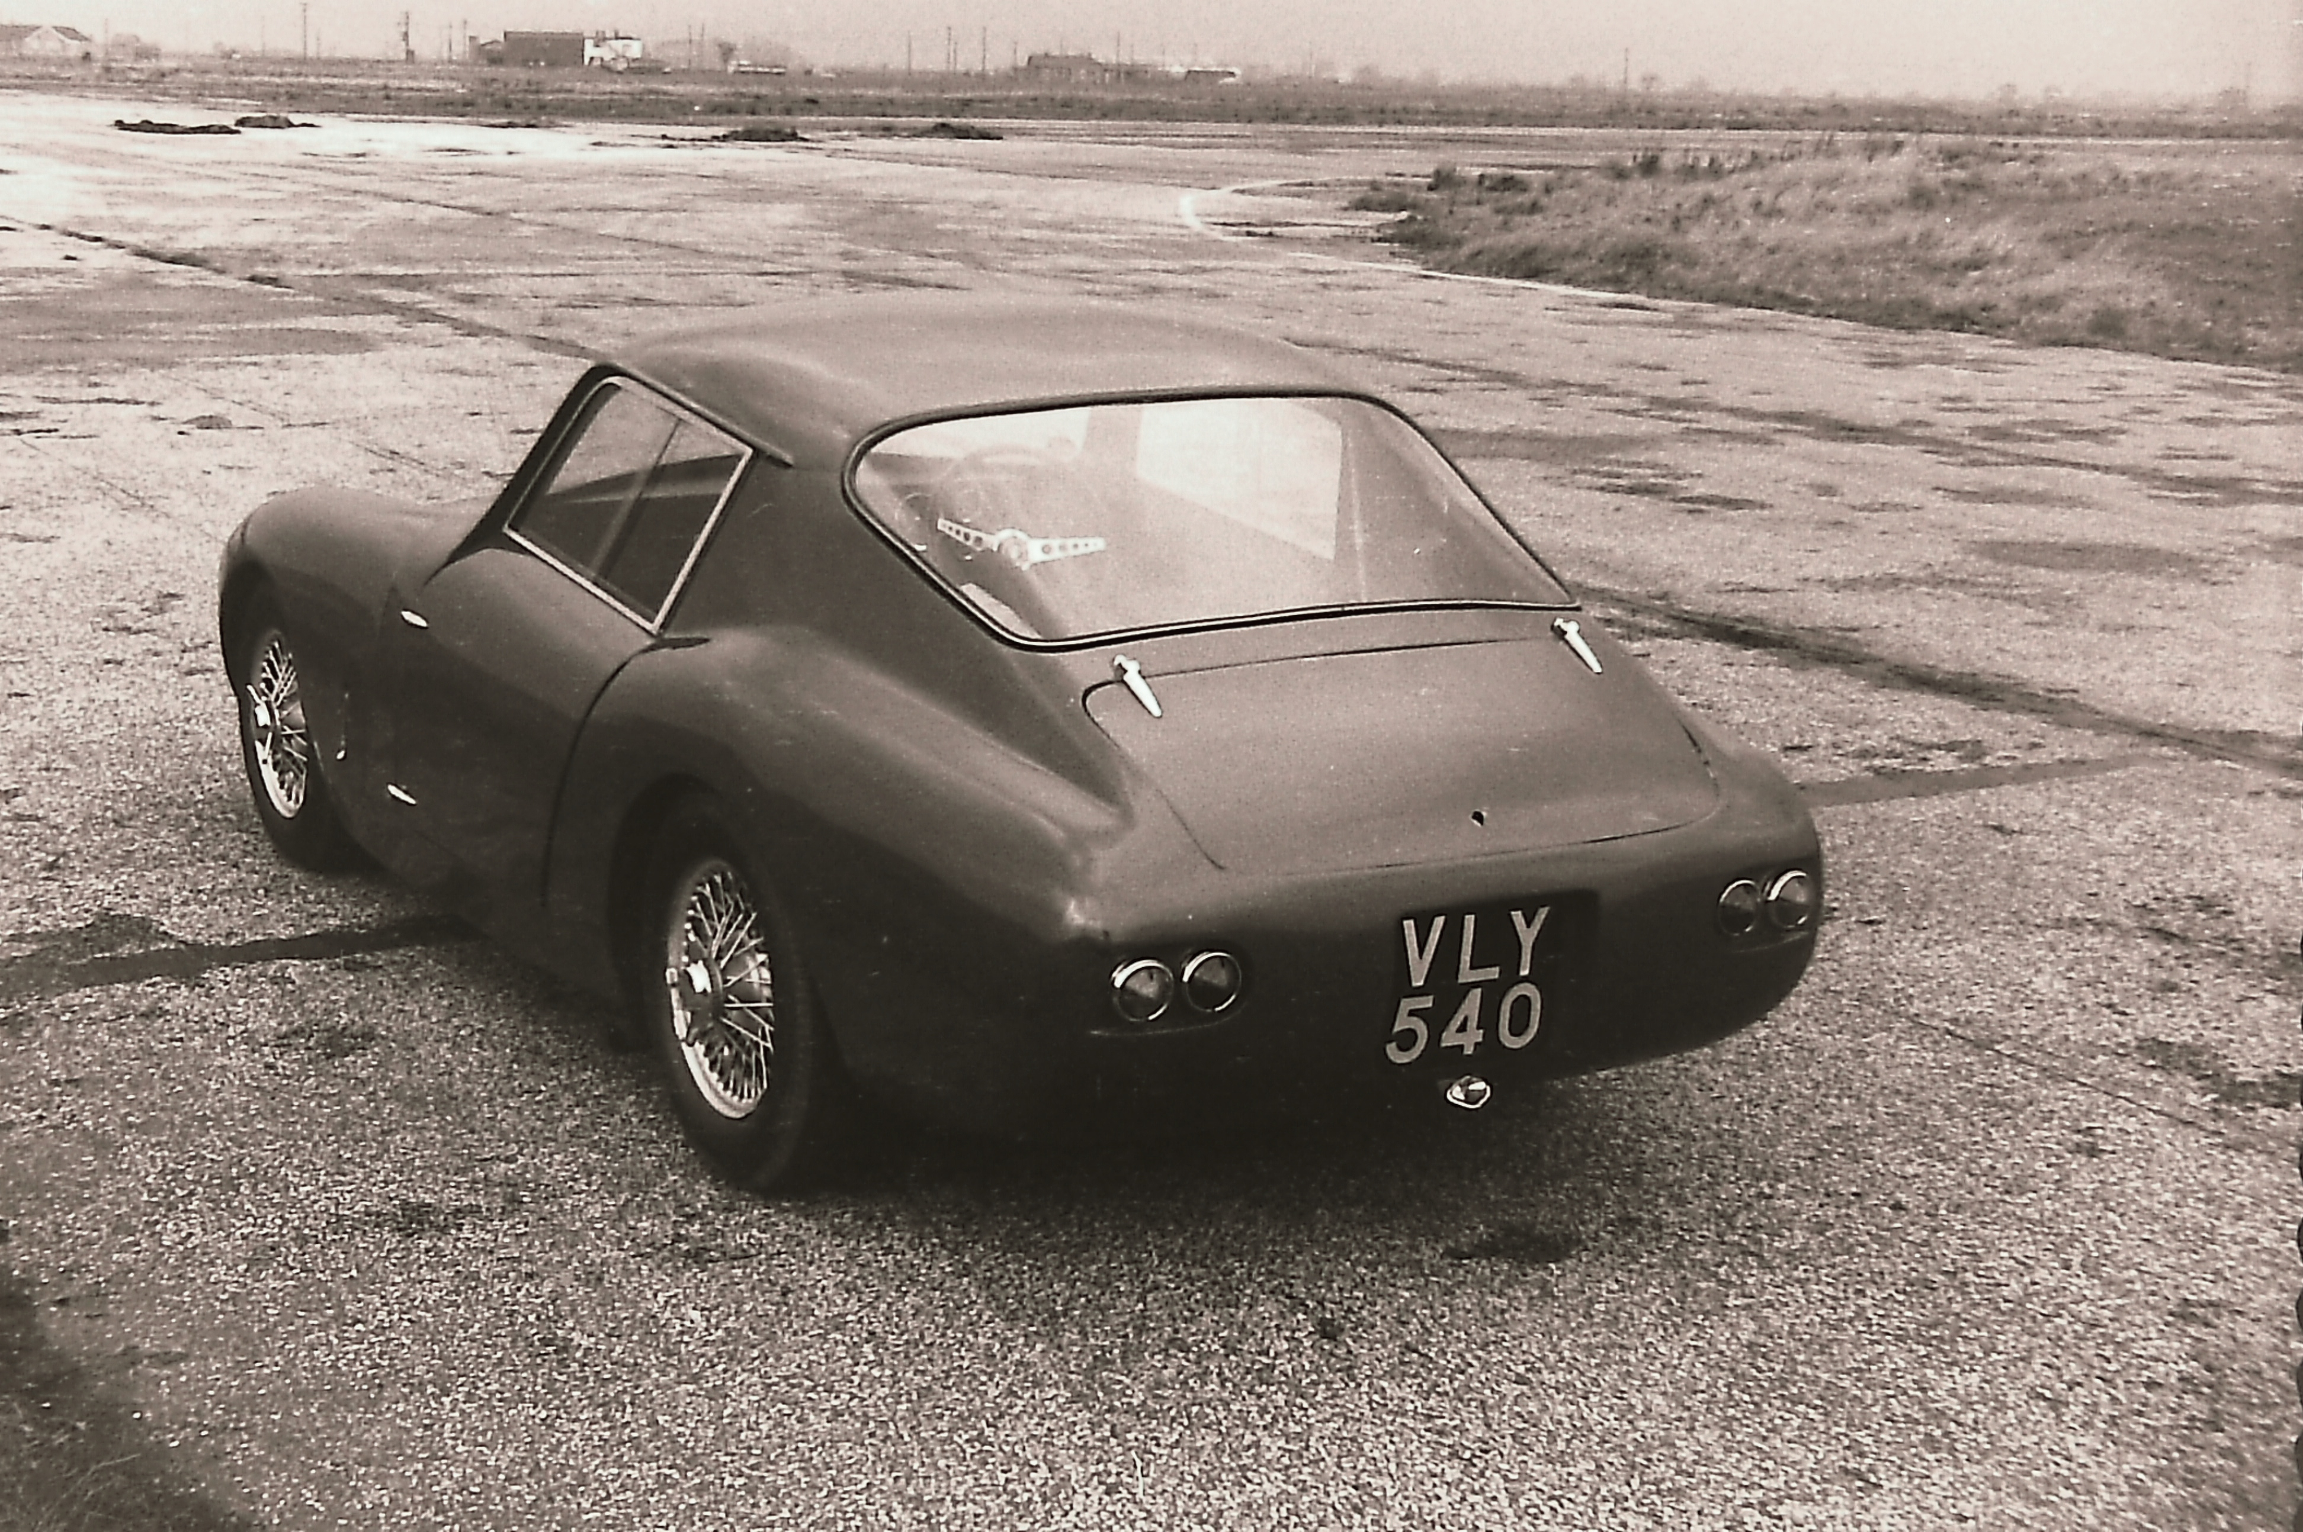

Registered VLY 540 in Geoff Hill’s ownership circa 1974 . .

